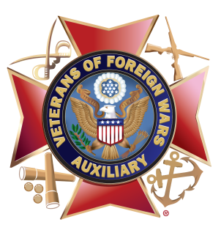
Facebook Posts for

VFW Auxiliary
Get Excited for the Red, White and Blue

National Anthem Singing Contest
Post #1
Spread patriotism through song! Youth in grades K-12 are encouraged to enter the VFW Auxiliary national anthem singing contest, Get Excited for the Red, White and Blue! Contestants may sing “The Star-Spangled Banner” in the arrangement and genre of their choice: rock, pop, reggae, R&B, hip-hop, country, classical and other genres are accepted. However, they can’t change the words! The contest consists of two grade divisions: K-8 and 9-12 with one national winner in each grade division receiving a $500 prize. Entries are due to a VFW Auxiliary by March 31, (year). Visit https://vfwauxiliary.org/what-we-do/youth-activities for contest eligibility, rules, national awards and an entry form.

Post #2
O Say Can Youth Sing? The VFW Auxiliary national anthem singing contest, Get Excited for the Red, White and Blue! is an opportunity for youth to share their talent, display their patriotism and express their creativity while singing “The Star-Spangled Banner.” They can also win one of two $500 national prizes! Video entries and signed entry forms are due to a VFW Auxiliary by March 31, (year). Visit https://vfwauxiliary.org/what-we-do/youth-activities for contest eligibility, rules, national awards and an entry form.

Post #3
Calling all youth in grades K-12 with a passion for patriotism. You’re invited to participate in the VFW Auxiliary national anthem singing contest, Get Excited for the Red, White and Blue! All genres, instruments and backing tracks are welcome for this solo vocal performance contest of “The Star-Spangled Banner.” You could win one of two $500 national prizes! Video entries and signed entry forms are due to a VFW Auxiliary by March 31, (year). Visit https://vfwauxiliary.org/what-we-do/youth-activities for contest eligibility, rules, national awards and an entry form.

Post #4
Share your talent, display your patriotism and express your creativity. Enter the VFW Auxiliary national anthem singing contest, Get Excited for the Red, White and Blue! Youth in grades K-12 are invited to sing “The Star-Spangled Banner” in the genre and arrangement of their choice – they just can’t change the words! The contest consists of two grade divisions: K-8 and 9-12 with one national winner in each grade division receiving a $500 prize. Video entries and signed entry forms are due to a VFW Auxiliary by March 31, (year). Visit https://vfwauxiliary.org/what-we-do/youth-activities for contest eligibility, rules, national awards and an entry form.

